Running a Successful VuGraph for Your Event on



Step by Step Instructions for Being a VuGraph Operator

Contents

Introduction 2
Installation 2
Access 2
A Trial Operation 3
The Fine Points 6
Entering the Closed Room Results 8
Allowing Commentators 9
Summary 10

Introduction
The VuGraph function of Bridge Base Online (BBO) is becoming increasingly popular among organizers of national and international events around the world. Users find it an excellent way of promoting bridge and highlighting the talents of the leading players in these world class events.

As BBO works to serve the bridge community in more and more exciting ways, we are gratified by the response we have received to our VuGraph feature. The demand has now outstripped our ability to attend all of these events and commentate on them. We have, however, found that the VuGraph system is easy to install, to understand, and to operate by almost anyone with an intermediate knowledge of computers and a passing knowledge of the game of bridge and the scoring systems in use in these kinds of competitions.

The simple steps found below should aid you in getting up and running, and in presenting your audience with an accurate, entertaining, and illuminating broadcast of the game that all of us love. If, upon working through the steps below, you find you are having some problems, please feel free to contact help at support@bridgebase.com.

Installation
First of all, if you are already using BBO to play bridge online or even just to kibitz, you already have most of what you need already loaded on your computer.

If you do not have BBO loaded on the computer you want to use for your VuGraph session, go to http://online.bridgebase.com/intro/download.php and follow the instructions to get the system loaded onto your machine.

Even if you already have BBO loaded on the computer you want to use for your VuGraph session, it is advisable to ensure you have the latest version of BBO loaded onto your machine as well.

IMPORTANT | If you are going to use an existing installation of BBO make sure you have your existing user name and password written down somewhere. If you set up a duplicate system, the BBO program will only remember the current password. Once you enter your VuGraph username and password, you will have to re-enter your regular username and password the next time you sign on to get back to your usual access.

Access
As a prospective VuGraph operator, we have provided you with a unique username and password for your VuGraph functions. These have already been installed into the system so you do not have to go in as a new user and, of course, this name and password gives you some special privileges. Your username and password were provided to you in the email that accompanied this document. But be careful - this password is case sensitive, so enter it with care.

A Trial Operation
In the e-mail that contained these instructions, there is a file called viewgraph.lin. Copy this demonstration file to the subdirectory where your BBO program is located (probably c:\bridge base online). This will give you some demo data to use in your first trials. We will talk about creating the actual user files later in this explanation.

You should have a screen icon for Bridge Base Online on your computer’s desktop. Click on that icon and you will get a box with three large buttons.

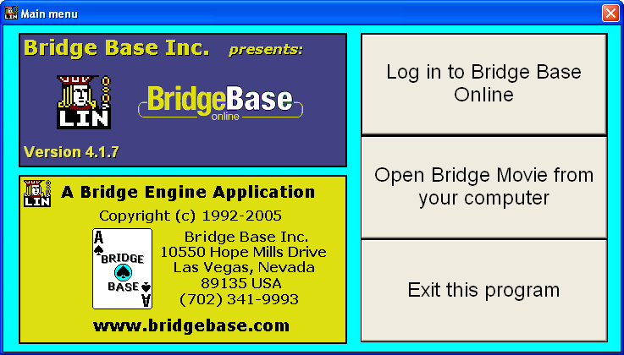 | Click Login to Bridge Base Online and you will see a login box.

Enter your assigned VuGraph username and password into the spaces provided. Make sure you click ‘Log in as invisible’ so your trials do not cause hundreds of users to flock to the VuGraph site to see your VuGraph. Using this sample data, you cannot create event and session information, but that, too, we will get to a little later. | 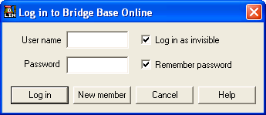

Once you get to the home screen, click on ‘Explore Bridge’ Button. | 

Now click on the VuGraph Theatre row (just as if you were going to watch VuGraph). | 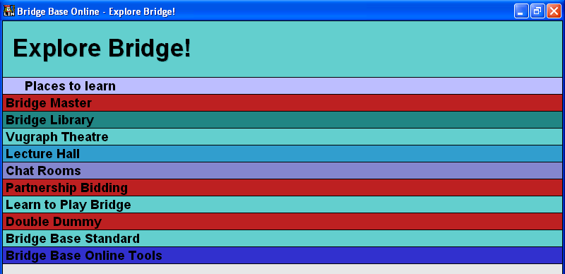

Now you will see the first feature which is different as a VuGraph operator. Instead of a notice of the next VuGraph broadcast, you will see a green box called Start Live Broadcast.
Click this button. | 
A window will open that asks if you wish to broadcast from the OPEN room or the CLOSED room or BOTH. |  | 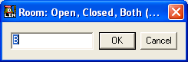

It is important to understand the meanings and implications of each choice.

If you are running single table coverage of a match, this means that you will be sole operator for this match. You should therefore choose ‘B’ for BOTH because you will be entering the score manually for the other room. (We’ll cover the mechanics of that later).

If you are running dual table coverage of a match, this means that both you and a friend or colleague will be covering both tables of the match. Whoever is covering the OPEN ROOM should log into BBO first and choose ‘O’ for OPEN. When your second operator (the person covering the CLOSED ROOM logs into the VuGraph Theatre they need to connect to your table in order to synchronize VuGraph broadcast from both tables and ensure the auctions and cardplay can be viewed for the other table.

To do so, the second operator needs to go to the VuGraph Theatre and look for the Open Room table of the match he wants to synchronize with:  When the operator clicks on this match, a message will appear:  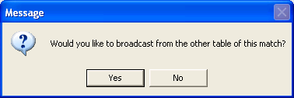  You MUST click on YES to synchronize the tables. | 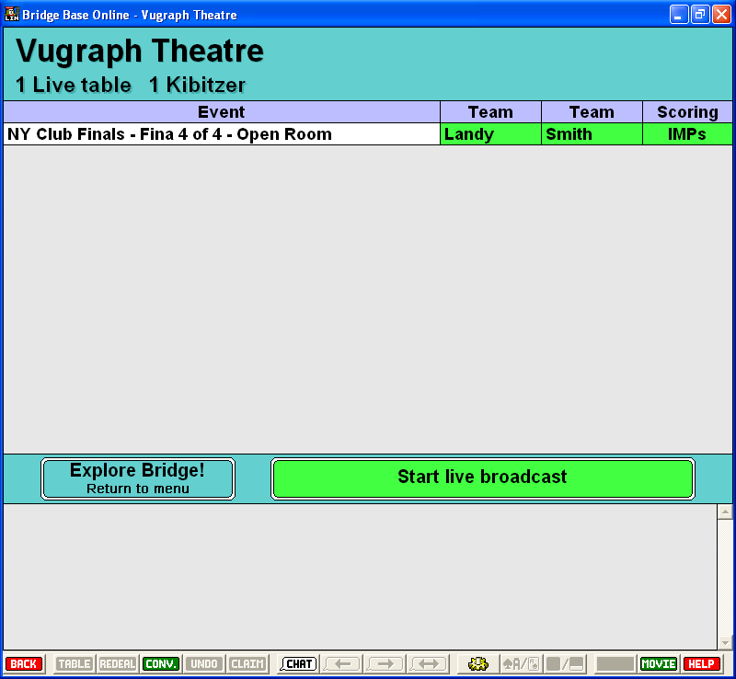

You are just about ready to get started. Before you do, it is important that you are comfortable with the layout of the screen. When you are in BBO, you can set up the screen to suit your own preferences.

Opens the Options window.
- Turn sound off.
- The rest as you please.

Displays either pictures of cards or the Index (A,K,Q…2).

Reduces or increases the chat area. Smaller chat area recommended.

When the players are seated, advise them that:
  - Other than confirming the number of tricks claimed at the end of a hand, generally there will be no communication with the players during the match. The VuGraph operator shall not under any circumstances disclose the running match-score.
  - It would be helpful if they fully release played cards and try not to obscure their cards when played.
  - It would be helpful if the 4th hand playing to each trick leaves his or her card face up for one or two seconds.
  - if they want to get up to leave the table during the match, make sure they comply with the tournament regulations and ensure that they do not walk behind or near the VuGraph operator.

Now all four hands will come up for the first board. You can enter the names of the four players in the correct positions by left clicking on their nameplate with your mouse and then entering the name.

The Name on Screen field is limited to 10 characters so you may need to do some judicious abbreviating.  The Real Name field has room for 30 characters, so you can insert the player’s full name here.  E-mail address: we’d suggest you keep this field blank.  Other information: There’s room for 99 characters to put in a brief biography or something nice about the player. | 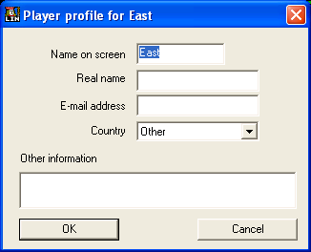

You will bid and play the cards for all 4 players. When it is a player’s turn to bid you will be able to click on Pass, Double, Redouble, or a number from 1 to 7 and then a symbol for clubs, diamonds, hearts, spades or no trump.  At the end of the auction (three passes after the last bid), it is time to play the cards. Just click on the card you want to play and it will appear in the centre of the screen in front of the player as if you are looking at the table from above. | 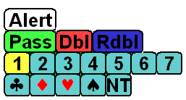

IMPORTANT: It is NEVER necessary to double click in this program! Only single click. If you double click, you might make some mistakes

When a deal is finished, it will remain on the screen until you are ready for another deal. When that time comes, click on the REDEAL button on the program’s toolbar.

A little window will appear. Type the letter O (as in open) plus the board number of the next board that should appear. If you are going in sequence, the next board should appear automatically and you simply click on ‘OK’ for the board to appear. |  | 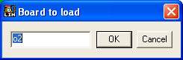
It is not good practice to put a board up on the VuGraph too long before play is initiated. While unlikely given the ethics of bridge players, it is possible that a player going off to the washroom might see all four hands on a VuGraph screen before sitting down to play.

UNDO: If you enter a wrong bid or card, you can use the UNDO button on the toolbar to take back the last bid/play made. This button can be used multiple times if necessary to get back to where you need to correct the mistake.
CLAIMS: If a player claims, or if you have been unable to follow the exact sequence of plays and need to enter a result, click the button on the toolbar. This will bring up the CLAIM box.  Always claim in terms of the declarer, even if it is a defender who claimed at the table. If the claim involves losing one or more tricks, you will need to adjust the claim using the Less button in the Claim box. | 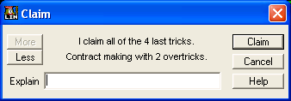
If you go too far you can adjust the claim upwards by using the MORE button. When you have it right, click on the CLAIM button in the CLAIM box to register the claim. Make sure the claim is correct and is accepted at the table before you enter it since it cannot be reversed once entered.

LOST CONNECTION: About the worst thing that can happen during a show is if you lose your connection to the Internet or our server. This is very unlikely if you have a reliable ISP. If it happens, just log in again and return to the VuGraph Theatre. You will get a message like:
Say ‘Yes’ if you were just disconnected. If you ever see this message and you were not disconnected, say ‘No’. | 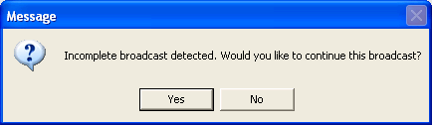

That’s pretty much all there is to it. Please give the software a try when you get a chance - I think you will find that it is very easy to do all of this. There are a few “finer points” discussed below that will make the broadcast more interesting and easier to manage, but it is best that you learn the basics first.

The Fine Points

Using Duplimate Files
We assume that you are using a Duplimate dealing machine to deal the cards for the event or have another way to get a computer file of the deal with a *.dup suffix. If you are not using a Duplimate machine, contact us at support@bridgebase.com and we will discuss alternate methods.

If you are using a Duplimate machine, you can instruct the Duplimate program, either using the native deal generator or something like the ACBL deal generator converted to Duplimate language, to give you a file with whatever file name you choose and the .dup extension. We have provided a sample .dup file as a companion file to the .lin file in the email attachments. It is called sample.dup and can be used for the next set of trials. We have supplied the sample.dup file for you to play with as well as the other files attached to the email that included these instructions.

To get that file into Bridge Base, follow these steps:

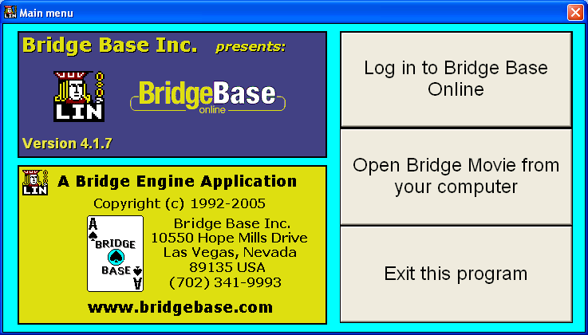 | Click on the Bridge Base Icon on your screen just as if you were going to log in.  Instead of logging in, click on the button that says ‘Open Bridge Movie from your Computer’.

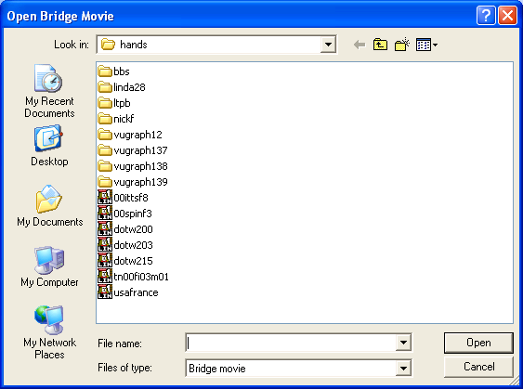 | You will see a listing of files and a window that says file name. Enter the path to the test dup file, including the filename and extension (sample.dup). When you are actually doing the VuGraph, your deals may come to you on a floppy disc. In that case, you should type a:<filename>.dup. In this case, for example, if you have copied the test file to a floppy, which can be the easiest way to go, you need simply type, a:sample.dup.

When you click on OPEN you will see a little window titled Name of Event. Type the name of the event that you will be broadcasting in that window. | 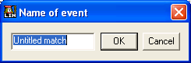

When you click on OK, you will get another window that asks for the Name of Segment. Most matches are divided into between 4 and 8 segments with comparative scoring after each segment. You probably want to start with Session 1 or Session 1 of 4 or something similar. | 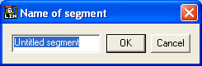

When you enter the name of this segment, you will see a window that allows you to select ‘I’ for an IMP match or ‘P’ for Pairs scoring. | 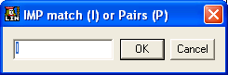

When that is selected (assuming you selected IMPs which is, of course, far the most common), you will be asked to enter the Name of the home team (this is the pair that sit North-South in the Open Room). Next you need to enter the Name of the away team (this is the pair that sit North-South in the Closed Room If you are going to broadcast a pairs game, since the teams will be constantly changing, the next question is the number of the first board.
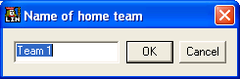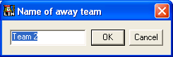

Next you can enter any IMP carryover for the home team (NS in the open room) and IMP carryover for the away team (EW in the open room). Remember the IMP carryover, in most cases, zero for the first segment of the match (but not always). For the second and subsequent sessions, you need to enter the current match score so that the running score remains accurate.
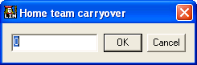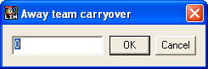
Finally, enter the number of the first board for this session. | 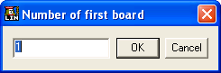

A pre-match will scorecard appear on your screen, looking something like this:  Now you can exit the program and log in as before. (Click on the screen icon, select Log In, enter your user name and your password, click enter (remember to use ‘invisible’ if you are practicing). | 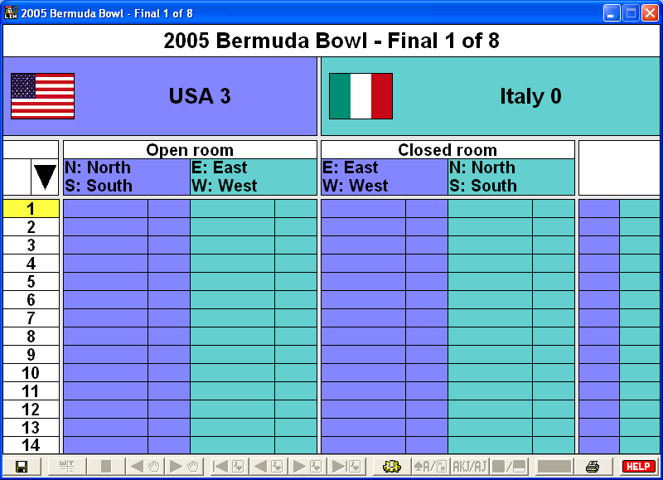

Entering the Closed Room Results
We suggest that you broadcast simultaneously from both the Open Room and Closed room of team matches, but you should be aware of the following:
- It requires twice as much equipment and 2 operators instead of one.
- It requires very careful setup.

Even if you do not have the resources to broadcast from 2 tables simultaneously, the broadcast becomes much more interesting if the viewers can at least see the results from the closed room as they become available. Sometimes the closed room results are known when the open room plays a board and sometimes the results from the closed room come much later. Either way, the provision of those closed room results adds to the suspense.

Click on the MOVIE button (bottom right of screen).

This is the Open Room Scorecard – to be able to input scores from the Closed Room you need to switch over to the Closed room.  Click on the Closed Room button (the black-filled rectangle at the top of the screen). | 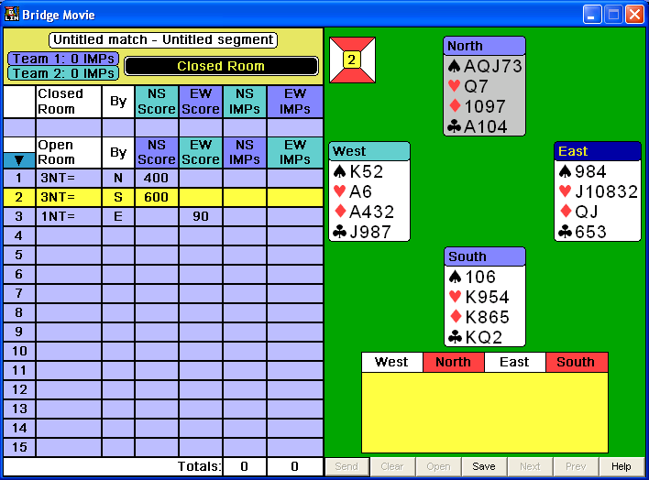

Notice how it says Closed Room in a white box in the 3rd row of the scorecard now.  Click anywhere on the line for the board whose results you wish to enter. | 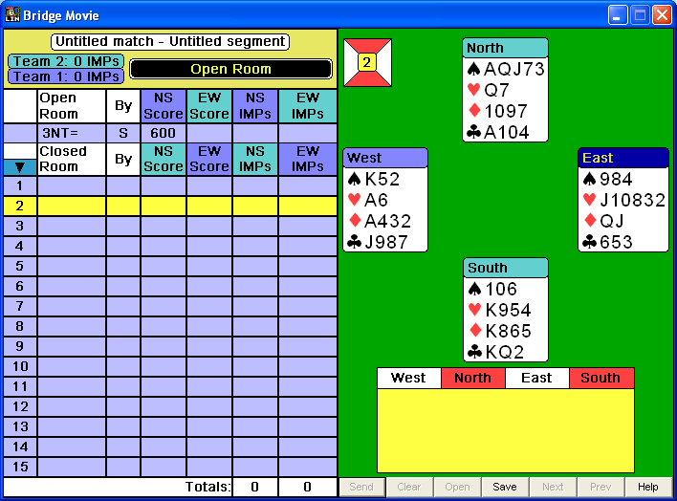

A small window will appear that will say ‘board x result’.  Enter the results exactly in the following order:  Contract Level / Strain / Declarer Seat / any X or XX / Result | 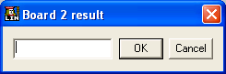

Some Examples:
  - 4 Hearts by East making 5 would be entered as 4he+1
  - 3 No Trump by North Doubled down two would be entered as 3nnx-2
  - 6 Spades by West redoubled and making would be entered as 6swxx=
  - A passed in hand is recorded as pass

It may take a little time (and possibly a cheat sheet along the top of your monitor), to get the coding down. However, once you have it, it works very well. And, of course, the computer can accurately calculate the result and the IMP margin on each board and overall. If the board has been played in the closed room and entered, it will show up on the open room screen as a notation. Also, of course, as it becomes known what the IMP margin is, it will be calculated on a running score basis.

Allowing Commentators
One of the joys of watching a well run VuGraph presentation is to have expert commentators involved in the broadcast. The VuGraph operator can, of course, comment as the match proceeds, but he or she is likely to be, as the saying goes, busy as a long tailed cat in a room full of rocking chairs. You will get much better quality commentary if you have several commentators on line. They need not be at the playing site.

Often, very good, internationally ranked players are quite willing to serve as commentators from their own homes or offices, sometimes on the other side of the world. Bridge Base has a roster of such players and we can usually find you several commentators if you wish. In addition, some local flavour can be added if commentators know the players and their tendencies and records.

Because unsolicited comments are distracting, VuGraph does not allow comments from all viewers. To permit a commentator to make comments online, do the following:
Ask your commentator to log on to the VuGraph just like a kibitzer. They can send you a personal message (to your VuGraph operator ID) to advise you that they are ready.  Find their name in the kibitzers list and right click on the name. You will see a very simple and self descriptive choice: gag and ungag. All kibitzers default to being gagged which prevents them from speaking to the entire audience. Just click on ungag and your commentator is ready to go. | 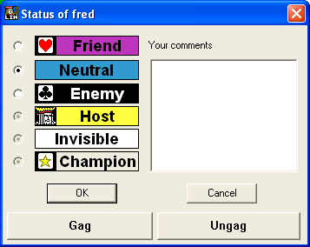

Take care not to ungag too many people or your broadcast will become a confusion of comments. Four or five commentators are usually sufficient.  Some commentators enjoy interacting with the audience via private questions and comments. As long as they have +++ in their ID profile, they can communicate with people in the audience. | 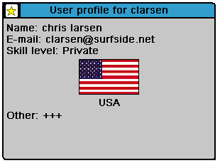

As a VuGraph operator, you can talk to anyone, although it’s quite likely you may not have much time for conversation.

You need to take some care in selecting your commentators. After several years’ experience we have discovered that the best commentators are:
- Able to type quickly (and accurately!).
- People who will not be critical or rude when players make mistakes (or try to prove how much smarter they are than the players). A good commentator must always try his best to make the players look good.
- Experienced players with reasonable bridge skills.
- Familiar with the players. Commentators who know the players can chat about their style, their experience with their partner, notable things they have done in the past, and the like.
- Someone who can think of something to chat about when the play is slow. In top competition, the misplay of a single card can mean the match, so players often sit for several minutes working out the options. This means that good chatters are sometimes good commentators.

Summary
Now you are ready to go. Take some time before the event to make sure everything is working. Remember to do it as invisible so you do not confuse other members. If you have problems, remember to write to support@bridgebase.com but do it well before the event. Trying to fix problems as play begins is not likely to give you a lot of success.

Oh, and by the way, once you have everything set to go, do send us information about your event and when the VuGraph is scheduled to operate so we can tell the world. We would love to promote your broadcast to our entire membership online.

Best of Luck
Sincerely,

Fred Gitelman
President, Bridge Base Online Inc.

